1. **Download and install MySQL:**

Link: <https://dev.mysql.com/downloads/windows/installer/>

The installer should allow you to install the following all at once:

**MySQL for Visual Studio**

**MySQL Workbench (optional, I think)**

**MySQL Connecter/NET**

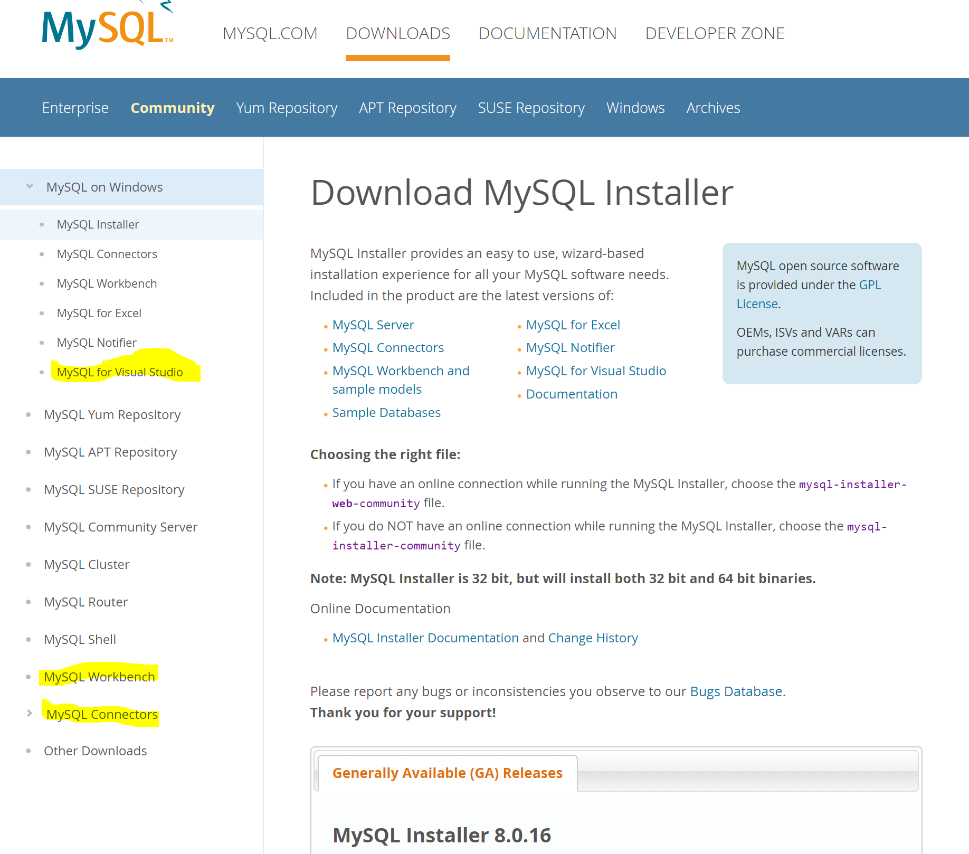

1. **Google “what’s my ip” and text it to me so I can allow it to connect to the db**
2. **Install the following NuGet packages in Visual Studio under Tools < NuGet Package Manager < Manage NuGet Packages for Solution (Note the versions)**

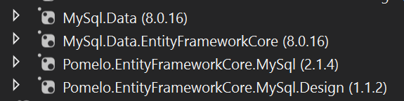

1. **Test DB connection:**

In Visual Studio, select View < Server Explorer

Hit “Connect to Database”

Hit “Change” under Data Source

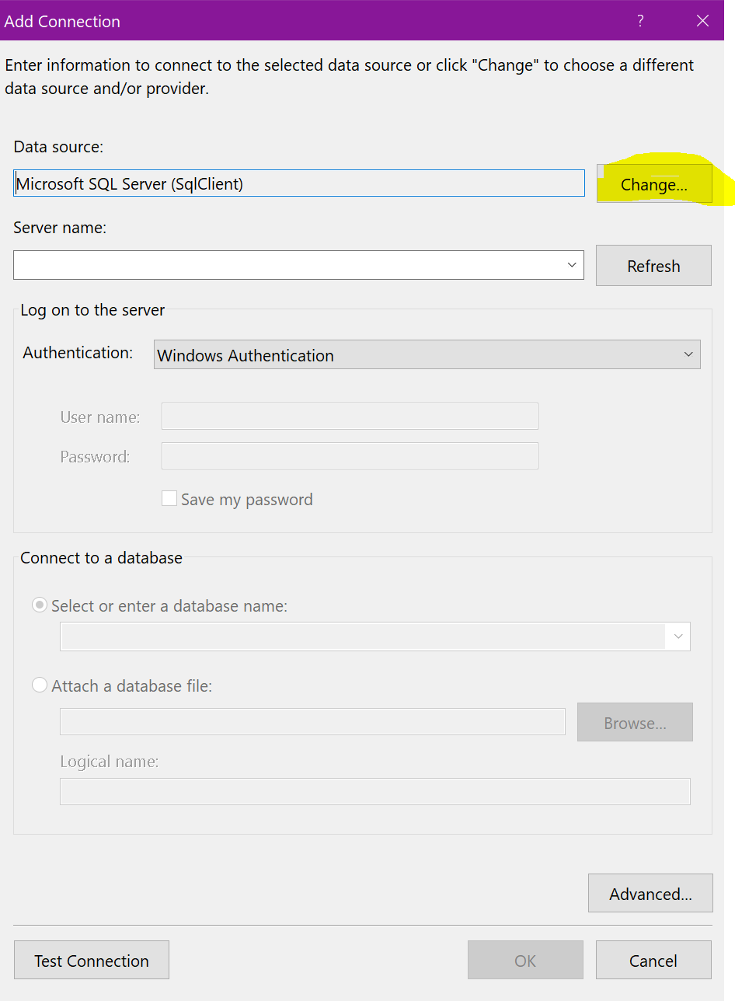

Select MySQL Database

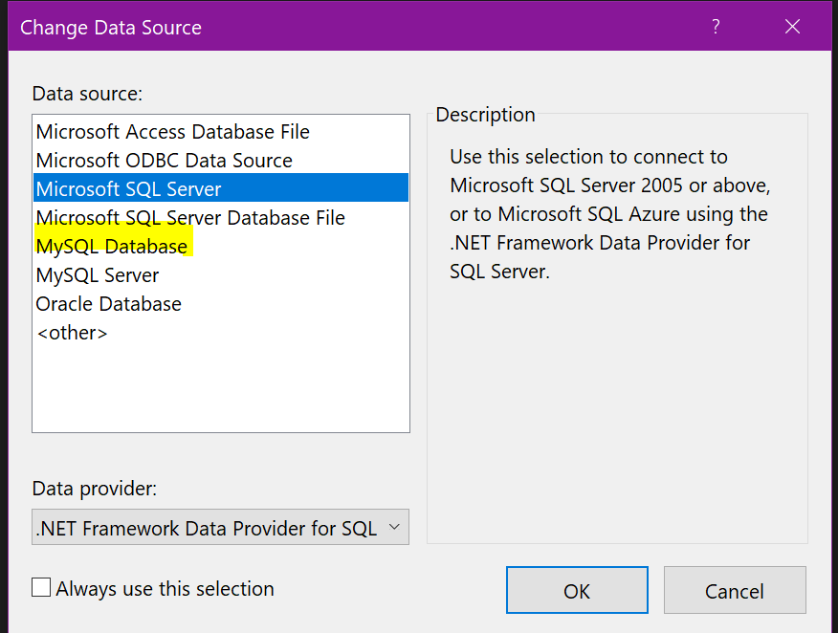

A new login view comes up

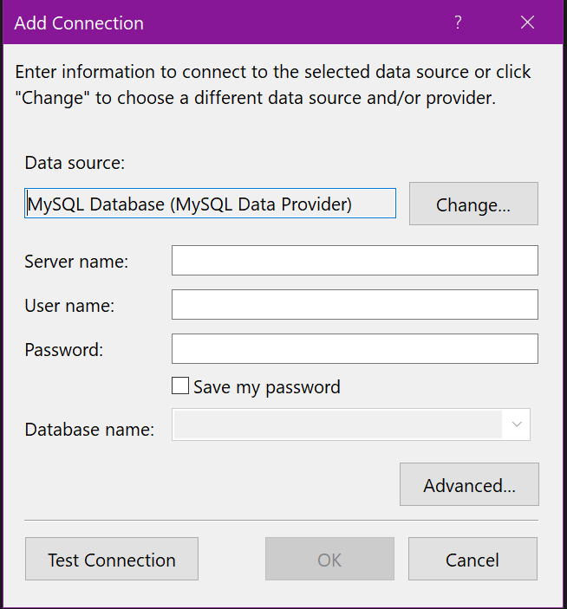

See image below for form values:



1. **Hit Test Connection, or OK if you like living on the edge**
2. **If successful, you will see the DB added to the Server Explorer**